# Deep Raider Collection: A Dive Into Vintage

**Price Segment:**

**Distinctive Sub- Families:**

**New Models:**

**Exceptional Movement:**

Positioned under 2,500 CHF.

The collection comprises two sub-families: Deep Raider Revival (39mm) and Deep Raider Renaissance (40mm).

4 new references – 1 model for the Deep Raider Revival and 3 for the Deep Raider Renaissance.

The collection features the exquisitely finished G100 movement from Manufacture La Joux-Perret, based in La Chaux-de-Fonds, Switzerland.

**Design:** As an ‘anniversary’ piece, the Deep Raider Revival honors the original design; the Deep Raider Renaissance offers a modern reinterpretation.

The **Deep Raider** collection pays homage to the brand’s rich history and technical prowess in dive watchmaking. First introduced in the 1960s, the **Deep Raider** quickly gained popularity for its robust design coupled with a water resistance down to 200 meters, a prized plus for its time.

The new collection, representing the ‘diver’ facet of Favre Leuba's relaunch, presents two flagship models: the **Deep Raider Revival** and the **Deep Raider Renaissance**. The former is a faithful reissue of the original 1964 model, while the latter is a modernized, more contemporary version.

# Deep Raider Revival: Celebrating our 60th Anniversary

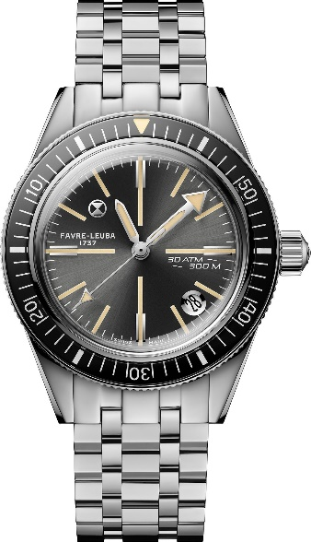To celebrate the 60th anniversary of the Deep Blue (1964-2024), Favre Leuba is reintroducing its iconic model as the **Deep Raider Revival**, absolutely true to its original design and 39mm dimensions. This reissue is set to captivate both newcomers and aficionados with its blend of tradition and modernity.

The **Deep Raider Revival** features a sunray-finished gray dial adorned with baton-shaped indexes from the original design, ensuring excellent readability. The iconic round date window at 4:30, with its polished and glossy finish, retains the look of 1964. The indexes and hands, subtly filled with

egg-shell colored Super-LumiNova® reminiscent of the radium used back then, evoke a vintage charm while guaranteeing remarkable legibility at all times, day or night. The

distinctive green glow in the dark enhances the watch’s unique identity and retro appearance. The hourglass emblem at 10 o'clock adds an extra distinctive touch.

The case, 39mm in diameter and 12.75mm in thickness, is designed and built for a water resistance of up to a depth of 300 meters, surpassing the 200 meters of the 60s model. All the professional dive watch boxes are ticked, including the unidirectional rotating bezel for calculating and monitoring no-stop dive times. This elegantly slim and robust case makes the Deep Raider Revival an ideal diver’s companion, offering exceptional wrist comfort both below and above sea level, in the wet or the dry. The solid case back, engraved with the ‘Favre Leuba 1737’ and hourglass emblem, is identical to its historical predecessor.

The **Deep Raider Revival** is powered by La Joux-Perret’s automatic G100 movement, ensuring a generous 68-hour power reserve, allowing you to leave your watch over the weekend and find it running accurately on Monday morning. This mechanism, entirely designed and produced by the prestigious Manufacture La Joux-Perret in La Chaux-de- Fonds, Switzerland, offers hour, minute, central second, and date functions.

The model introduced in 1964 had an acrylic crystal; the new reincarnation boasts a sapphire crystal for increased durability. The bezel, made of bakelite back in the day, has been replaced with a sapphire insert printed on the back, faithfully reproducing the original’s look. The visual effect of depth is preserved, with the added bonus of superior scratch resistance. The luminous triangle at 12 o'clock and the white printed scale remain, as before, key identifying features. While these material improvements reflect contemporary standards and production techniques; they fully respect the vintage spirit.

Priced at 2,000 CHF, the **Deep Raider Revival** embodies the spirit of innovation and excellence that has defined the brand since its inception, a watch that integrates modern technical features while honoring its heritage. The steel bracelet, too, stays true to the original design with its 5-link construction featuring triangular links. Featuring a deployant clasp, its subtle satin-brushed steel sheen captures the light, adding a note of sophistication and elegance.

# Deep Raider Renaissance

The **Deep Raider Renaissance** is the cousin of the Deep Raider Revival, but with bolder features and an enhanced, modernized aesthetic signature. It has been redesigned with a fresh,

contemporary approach, highlighting a harmonious blend of design and functionality, and careful attention to detail. It oozes sophistication.

The **Deep Raider Renaissance**’s dial comes in three captivating shades: deep blue, intense green, and anthracite gray. It showcases a striking smoked effect, with a gradient color that is lighter at the center and darker at the edges. White Super-LumiNova®, glowing blue in the dark, ensures perfect legibility under any circumstance. The dial elements, such as the resized logo and hands, have been repositioned for a decidedly contemporary look.

Beneath the dial, the beautifully decorated La Joux-Perret G100 movement – which is visible through the sapphire case back, offering a stunning view of the refined mechanism. Enhanced water resistance up to 300 meters guarantees exceptional performance, even in the most demanding underwater environments. The enlarged screw-down crown, engraved with an hourglass emblem, completes this robust design and ensures maximum water protection against water ingress.

Besides the fundamentals such as hour, minute, and central second, the **Deep Raider Renaissance** features a date function with a window at 4:40. Naturally, it ticks off the key essentials of a dive watch, a unidirectional rotating bezel. Adapted in ceramic for the slightly larger 40mm case, the combination of the sleek material with a new numeral design projects a modern, purpose-designed vibe.

The **Deep Raider Renaissance** is available with a rubber strap or the completely redesigned ‘3-link’ steel bracelet, both featuring a quick-change interchangeability system for versatility. Note the curved lugs that add a bold touch to the overall design, giving the watch a modern vintage charm.

Favre Leuba’s **Deep Raider** collection celebrates six decades of horological excellence, blending the brand’s historical designs with the latest in engineering. Each piece pays homage to the spirit of perpetual innovation that defines Favre Leuba. The **Deep Raider Renaissance**, priced at 2,200 CHF, embodies this legacy with an elegant, modern take.